AI WeatherWise – Deliver Intelligent Weather Forecasts and Insights

PROJECT DESCRIPTION:
AI WeatherWise is a smart weather assistance system developed to provide useful weather information in a simple and understandable format. The application combines a backend server, database, weather data service, and Artificial Intelligence to process weather-related information.
The system allows users to search for weather conditions based on a selected location. The collected information can include temperature, humidity, wind speed, and general weather conditions. AI processing is used to convert these details into meaningful descriptions and practical suggestions.
The application also provides user account management and saved-location functionality. This allows users to securely access the system and maintain locations that they frequently check. The project demonstrates how AI can be combined with real-time data to create a more useful weather application.
SCENARIO:
Problem:
Weather information is usually presented through numbers, icons, and technical details. Users may see temperature, humidity, wind speed, and other values but may not immediately understand what these conditions mean for their daily activities. Checking different locations repeatedly can also be inconvenient..
AI Solution:
AI Weather Wise processes weather information and uses AI to explain the conditions in a more natural and readable manner. Instead of depending only on numerical values, the system can generate a short description of the current weather and provide suggestions related to daily activities.
Impact:
AI Weather Wise makes weather information easier to understand and more convenient to use. The combination of real-time weather information and AI-generated explanations helps users interpret weather conditions quickly. The saved-location feature also reduces the effort required to search for frequently used places.
SYSTEM REQUIREMENTS:
AI Weather Wise requires software and hardware resources for application development, database management, weather-data retrieval, AI processing, and API testing. A stable development environment and internet connection are required because the application communicates with external services.
1. Software Requirements
Operating System: Windows 10/11, macOS, or Linux can be used for development and execution.
Node.js: Provides the runtime environment for executing the backend JavaScript code and running the Express server.
npm: Used to install and manage required project packages and dependencies.
Express.js: Used to create REST APIs, manage routes, process requests, and return responses.
MongoDB Atlas: Used as the cloud-based NoSQL database for storing registered users and favorite-location details.
Mongoose: Provides schema definition, validation, and communication between Node.js and MongoDB.
OpenWeather API: Retrieves current weather information such as temperature, humidity, wind speed, and weather condition.
Google Gemini AI: Generates natural-language weather summaries and personalized recommendations.
Thunder Client: Used to test the REST APIs inside Visual Studio Code.
Visual Studio Code: Used as the development environment for writing, running, and testing the project.
2. Hardware Requirements
Processor: Intel Core i5 / AMD Ryzen 5 or equivalent.
RAM: Minimum 8 GB recommended for smooth development.
Storage: At least 5 GB of free disk space.
Internet Connection: Required for accessing MongoDB Atlas, OpenWeather API, Gemini AI, and GitHub.
Display: 1366 × 768 resolution or higher is recommended.
PROJECT ARCHITECTURE
AI Weather Wise follows a modular architecture in which different parts of the application perform separate responsibilities. This makes the system easier to understand, maintain, test, and improve.
The backend manages user requests and application logic, while the database stores required information. External weather services provide current weather data, and the AI component interprets this information to generate useful responses.
Technical Architecture
The major components of the AI WeatherWise architecture are described below.
1. Backend Layer
The backend layer receives requests from the client, processes application logic, communicates with different services, and returns JSON responses. It handles user registration, login, favorite-location operations, weather requests, AI summaries, and recommendations.
2. Database Layer
MongoDB Atlas is used to store user details and favorite locations. Mongoose is used to define schemas and perform database operations.
3. Weather Service Layer
The Weather Service communicates with the OpenWeather API and retrieves current weather details such as temperature, humidity, wind speed, and weather condition.
4. AI Layer
Google Gemini AI processes weather information and generates easy-to-understand summaries and personalized suggestions such as clothing advice, hydration guidance, and outdoor activity recommendations.
5. Security Layer
Security is implemented using JWT authentication, bcrypt password hashing, protected routes, authentication middleware, and input validation.
6. API Testing Layer
Thunder Client is used to test the major APIs, including Register, Login, Favorite Location CRUD, Weather, Weather Summary, and Weather Recommendation. This is the medium-sized level I would use for the whole document. It should keep the report informative without making it too long.
Architecture Flow:
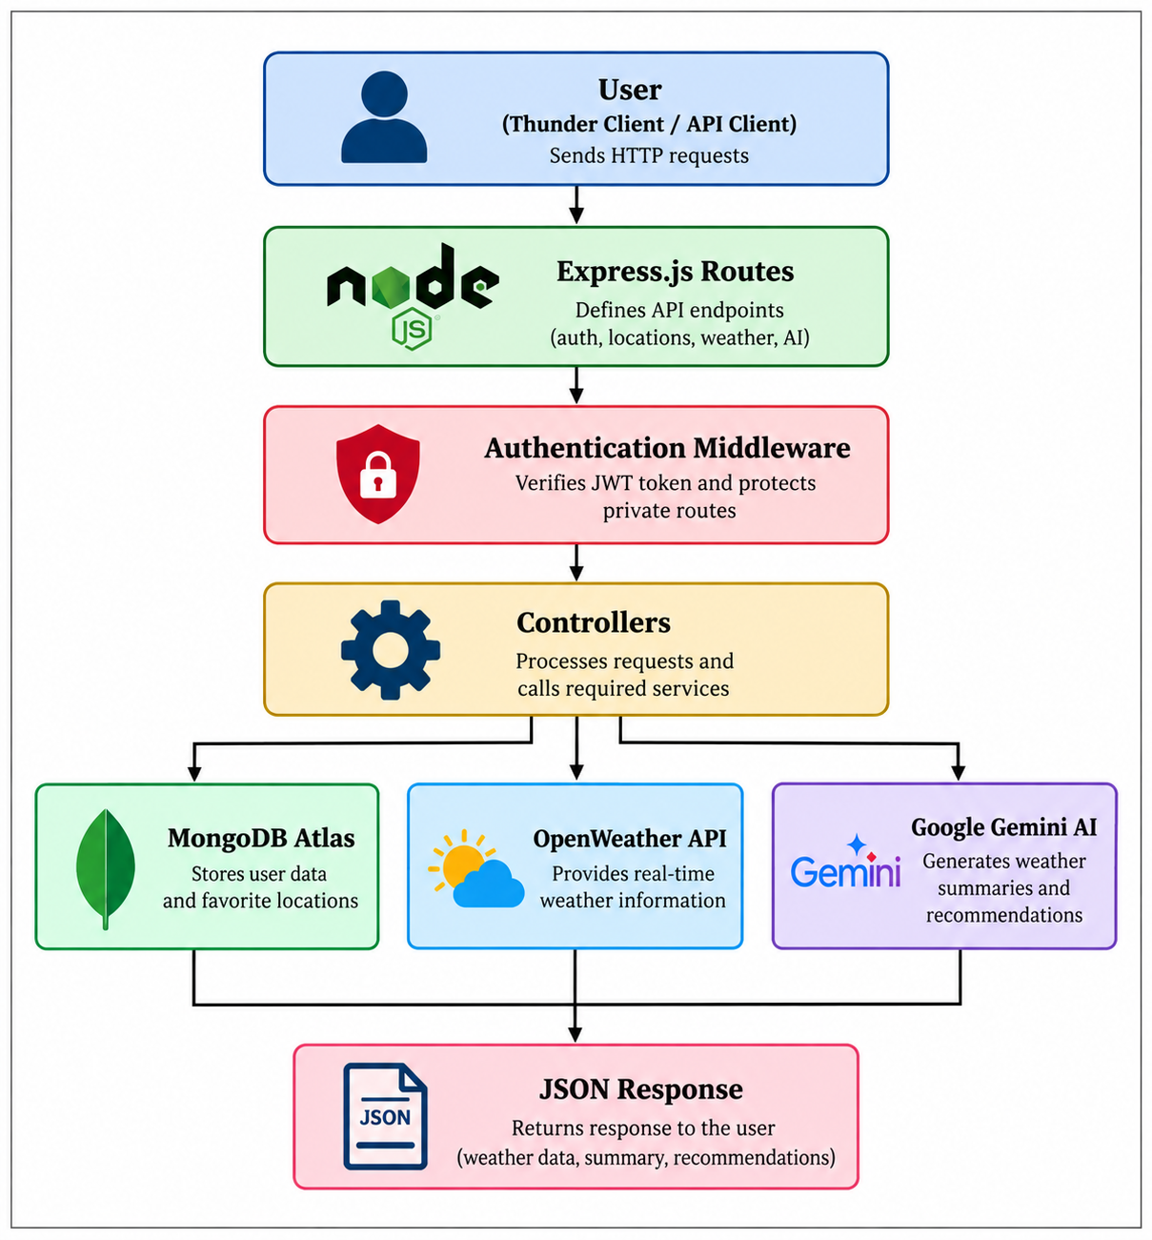
Fig1. AI-WeatherWise Architecture Flow
ER DIAGRAM
The Entity-Relationship Diagram represents how information is organized within the AI WeatherWise database. The major entities are User and Location.
User Entity:
The User entity stores the details of registered users.
Main attributes:
- _id – Unique identifier for each user
- name – Name of the user
- email – Registered email address
- password – Password stored in hashed form using bcrypt
- createdAt – Account creation date and time
- updatedAt – Last updated date and time
Location Entity:
The Location entity stores the favorite locations saved by users.
Main attributes:
- _id – Unique identifier for each location
- city – Name of the city
- country – Name of the country
- user – Reference to the user who saved the location
- createdAt – Date and time when the location was created
- updatedAt – Last updated date and time

Relationship
A one-to-many relationship exists between the User and Location entities. This relationship helps the application maintain separate saved-location information for different users. When an authenticated user requests saved locations, the system can identify and display only the locations belonging to that user.
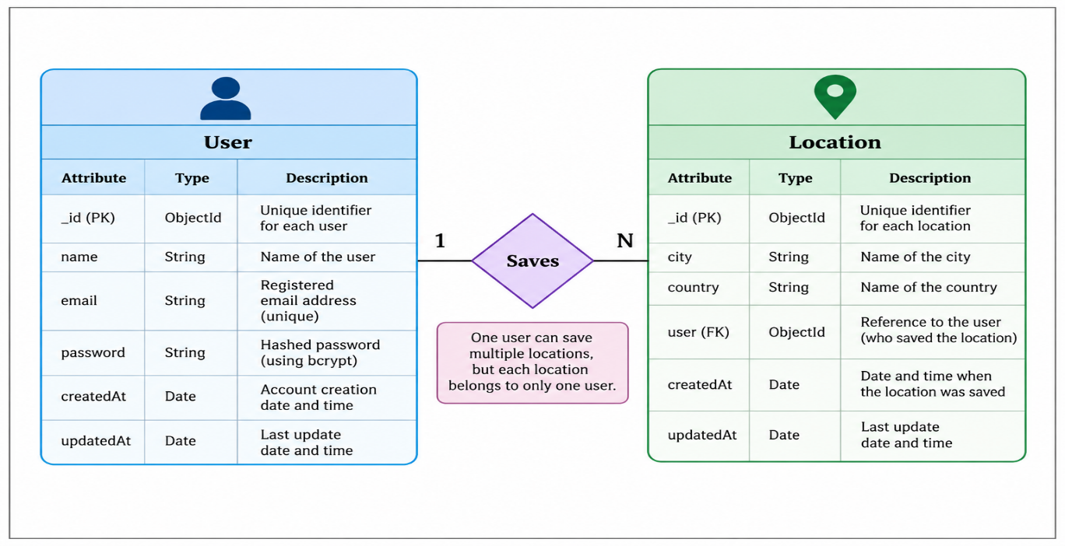
Fig2. AI-WeatherWise ER Diagram
ER DIAGRAM EXPLANATION
The ER diagram provides a simple representation of the database structure used by AI Weather Wise. The User entity contains information related to registered accounts, while the Location entity contains information about places saved by users.
The relationship between the two entities allows the application to connect each saved location with its respective user. This structure prevents saved locations from being mixed between different accounts.
The database design also makes it easier to perform operations such as adding a new location, displaying saved locations, modifying an existing location, and deleting a selected location.
FEATURES:
AI Weather Wise contains several features that work together to provide a complete weather information service. The main features include user management, weather retrieval, AI processing, and saved-location management.Core Backend Features
User Registration:
Allows new users to create an account using their name, email address, and password.
User Login:
Registered users can log in using their email and password. After successful authentication, a JWT token is generated.
JWT Authentication:
JSON Web Tokens are used to verify authenticated users and protect private API routes.
Password Hashing:
User passwords are encrypted using bcrypt before being stored in MongoDB Atlas.
Favorite Location Management:
Authenticated users can add, view, update, and delete favorite locations.
Real-Time Weather Retrieval:
The system retrieves current weather information from the OpenWeather API based on the requested city.
MongoDB Atlas Integration:
MongoDB Atlas stores user information and favorite-location data securely.
REST API Support:
The application uses HTTP methods such as GET, POST, PUT, and DELETE for performing backend operations.
AI Features:
AI Weather Summary:
Google Gemini AI generates a simple natural-language summary from the current weather information.
Personalized Weather Recommendations:
The AI provides useful suggestions based on weather conditions, such as clothing recommendations, hydration advice, and outdoor activity guidance.
AI-Powered Weather Insights:
Raw weather values are converted into understandable information that helps users make better daily decisions.
ROLES AND RESPONSIBILITIES
Registered User
The registered user is the main user of AI WeatherWise. The user can create an account, log in securely, manage favorite locations, check real-time weather information, and obtain AI-generated summaries and recommendations.
The main responsibilities of the user include:
- Registering and logging into the system
- Using the JWT token for protected APIs
- Adding, viewing, updating, and deleting favorite locations
- Requesting current weather information
- Viewing AI-generated weather summaries
- Receiving personalized weather recommendations
System / Backend
The backend manages all application operations and coordinates communication between MongoDB Atlas, OpenWeather API, and Google Gemini AI.
Its main responsibilities include:
- Validating registration and login requests
- Hashing passwords using bcrypt
- Generating and verifying JWT tokens
- Managing favorite-location data
- Retrieving real-time weather information
- Sending weather information to Gemini AI
- Returning structured JSON responses
- Handling invalid requests and API errors safely
USER FLOW
The user flow explains how a user interacts with AI WeatherWise from account creation to receiving weather information and AI-generated insights.
- User Registration – A new user creates an account using name, email, and password.
- User Login – The registered user logs in using email and password.
- JWT Authentication – The backend generates a JWT token after successful login.
- Manage Favorite Locations – The authenticated user can add, view, update, or delete favorite locations.
- Request Weather Information – The user enters a city to obtain current weather details.
- Fetch Weather Data – The backend retrieves real-time information from OpenWeather API.
- Generate AI Summary – Weather information is processed using Google Gemini AI.
- Generate Recommendations – Gemini AI provides personalized weather-based suggestions.
- Return Response – The backend returns weather data, summary, or recommendation as JSON
User Flow Representation:
The user flow describes the complete sequence followed by a user while interacting with AI WeatherWise.

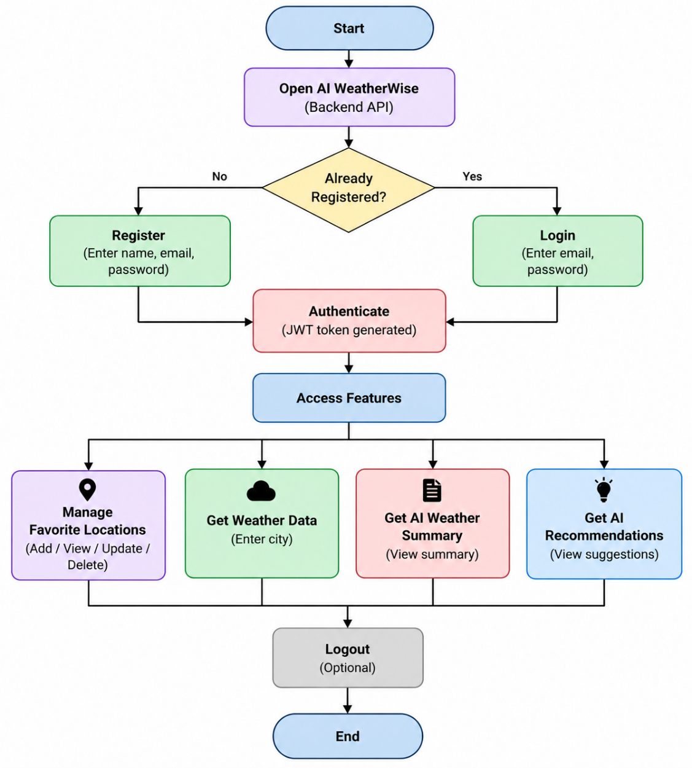
MVC PATTERN
AI Weather Wise uses the Model-View-Controller pattern to separate different responsibilities within the backend application. This approach makes the source code more organized and allows individual components to be developed and maintained independently.
Model Layer
The Model layer defines the structure of data stored in MongoDB Atlas using Mongoose.
Main models:
User.js
- Stores name, email, password, and user information.
Location.js
- Stores city, country, user reference, and timestamps.
Controller Layer
The Controller layer contains the main business logic.
authController.js - handles registration, login, JWT generation, and password verification.
locationController.js - handles favorite-location CRUD operations.
weatherController.js - handles real-time weather requests.
aiController.js - handles AI-generated summaries and recommendations.
View Layer / Routes
The route files define the API endpoints used by the application.
- authRoutes.js – Registration and login
- locationRoutes.js – Favorite-location operations
- weatherRoutes.js – Weather retrieval
- aiRoutes.js – AI summary and recommendations
Service Layer
weatherService.js - communicates with the OpenWeather API.
aiService.js - communicates with Google Gemini AI and generates weather-related responses.
Middleware Layer
authMiddleware.js - verifies JWT tokens and protects private routes from unauthorized access.
Advantages of MVC
MVC improves code organization, simplifies debugging, supports code reuse, and makes future enhancements easier.
PROJECT SETUP AND CONFIGURATION
AI Weather Wise is organized as a backend project with separate areas for configuration, models, controllers, routes, middleware, and services.
This organization allows developers to locate required files easily and maintain the project as new features are added.
Project Structure
The backend project contains the following main files and folders:
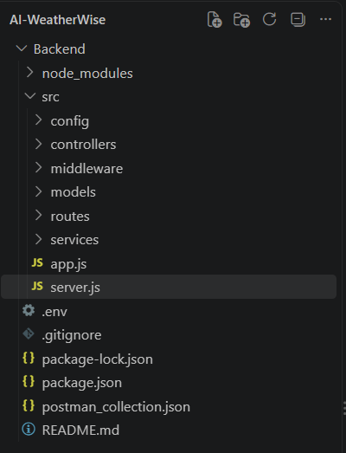
Project Initialization
The AI WeatherWise backend project was initialized using npm. The following command was used:
npm init -y
This command creates the package.json file, which stores the project details, scripts, and required dependencies.
Installation of Backend Packages
The required backend packages were installed using npm. These packages support REST API development, MongoDB connectivity, authentication, external API communication, and AI integration.
npm install
This command installs all dependencies listed in the package.json file.
Environment Configuration
Sensitive information such as database credentials, JWT secrets, and API keys is stored in the .env file.
PORT=5001
MONGO_URI=your_mongodb_connection_string
JWT_SECRET=your_jwt_secret
OPENWEATHER_API_KEY=your_openweather_api_key
GEMINI_API_KEY=your_gemini_api_key
The .env file is included in .gitignore to prevent confidential credentials from being uploaded to GitHub.
BACKEND DEVELOPMENT
The AI WeatherWise backend is developed using Node.js and Express.js. It manages user authentication, favorite-location operations, weather retrieval, and AI-generated weather insights. MongoDB Atlas is used for data storage, OpenWeather API provides real-time weather information, and Google Gemini AI generates summaries and recommendations.
Authentication API
The authentication module manages user registration and login.
During registration, the user provides a name, email address, and password. The password is hashed using bcrypt before being stored in MongoDB Atlas. During login, the entered password is compared with the stored hashed password. If the credentials are valid, the backend generates a JWT token for authentication.
JWT Authentication
JSON Web Token authentication is used to secure protected routes. After successful login, the user receives a JWT token.
The token is sent in the Authorization header in the following format:
Authorization: Bearer <JWT_TOKEN>
The authentication middleware verifies the token before allowing access to protected APIs such as favorite-location management.
Favorite Location CRUD API
The Favorite Location module allows authenticated users to manage preferred cities.
The supported operations are:
POST /api/locations
GET /api/locations
PUT /api/locations/:id
DELETE /api/locations/:id
These APIs allow users to add, view, update, and delete favorite locations. The system also ensures that users can modify only their own saved locations.
Weather API Integration
The Weather API retrieves current weather information for a requested city using the OpenWeather API.
The response may include:
- City name
- Temperature
- Humidity
- Wind speed
- Weather condition
The retrieved weather information is also used by the AI module to generate summaries and recommendations.
Gemini AI Integration
Google Gemini AI is integrated with AI WeatherWise to convert weather data into easy-to-understand text.
The project provides two main AI functions:
Weather Summary: Generates a simple natural-language explanation of the current weather.
Weather Recommendation: Provides personalized suggestions such as suitable clothing, hydration advice, and outdoor activity recommendations.
Purpose of Gemini API
The Gemini API is used to interpret raw weather values and generate meaningful weather insights. This makes the weather information easier for users to understand and apply to their daily activities.
Request Structure
The backend sends relevant weather information such as temperature, humidity, wind speed, and weather condition to Gemini AI.
Example:
{
"city": "Chennai",
"temperature": 32,
"humidity": 70,
"condition": "Cloudy"
}
Response Structure
Gemini AI returns a generated text response.
Example summary:
{
"summary": "The weather is warm and humid with cloudy conditions."
}
Example recommendation:
{
"recommendation": "Wear light clothing, stay hydrated, and carry an umbrella if going outside."
}
Cost Considerations:
External weather and AI services may provide different usage limits depending on their plans. The application should request external services only when necessary. Avoiding repeated or unnecessary API calls can help reduce service usage.
Security Practices:
Security is an important part of the Weather Wise application. Sensitive credentials should not be directly written inside source-code files.
DATABASE DEVELOPMENT
AI Weather Wise uses MongoDB Atlas as its cloud-based NoSQL database. Mongoose is used to define schemas, validate data, and perform database operations.
MongoDB Collections
The project mainly uses two collections:
Users Collection
The Users collection stores registered user information.
Main fields include:
_id
name
email
password
createdAt
updatedAt

The password is stored in hashed form using bcrypt.
Locations Collection
The Locations collection stores the favorite locations saved by registered users.
Main fields:
_id
city
country
user
createdAt
updatedAt
The user field stores the ObjectId of the user who saved the location.
Database Relationship
One user can have multiple saved locations. This structure allows every account to maintain its own list of frequently used places.
When a user requests saved locations, the backend can use the user identification information to retrieve the appropriate records.
Database Validation
Mongoose schemas are used to validate the data before it is stored in MongoDB Atlas. Validation includes required user details, unique email addresses, required city and country fields, and user references for favorite locations. The Location model also prevents duplicate city and country combinations for the same user.
PROJECT EXECUTION
The AI Weather Wise backend is executed locally using Node.js. Before running the project, the required dependencies and environment variables must be configured correctly.
Step 1 – Install Dependencies
Open the project folder in Visual Studio Code and run:
npm install
This command installs all the packages listed in the package.json file.
Step 2 – Configure Environment Variables
Create or update the .env file with the required configuration values.
PORT=5001
MONGO_URI=your_mongodb_connection_string
JWT_SECRET=your_jwt_secret
OPENWEATHER_API_KEY=your_openweather_api_key
GEMINI_API_KEY=your_gemini_api_key
The actual keys and credentials should remain private and should not be uploaded to GitHub.
Step 3 – Start the Backend Server
Run the backend using:
npm run dev
After successful execution, the terminal should show that the database is connected and the server is running.
Example:
MongoDB Connected
Server running on port 5001
The backend can then be accessed using:
http://localhost:5001
Step 4 – Test the APIs
After the backend starts successfully, the REST APIs are tested using Thunder Client in Visual Studio Code.
The main APIs tested are:
- Register API
- Login API
- Add Favorite Location API
- View Favorite Locations API
- Update Favorite Location API
- Delete Favorite Location API
- Weather API
- Weather Summary API
- Weather Recommendation API
OUTPUT SCREENSHOTS:
1. Register API
The Register API creates a new user account using name, email, and password. The password is hashed before being stored in MongoDB Atlas.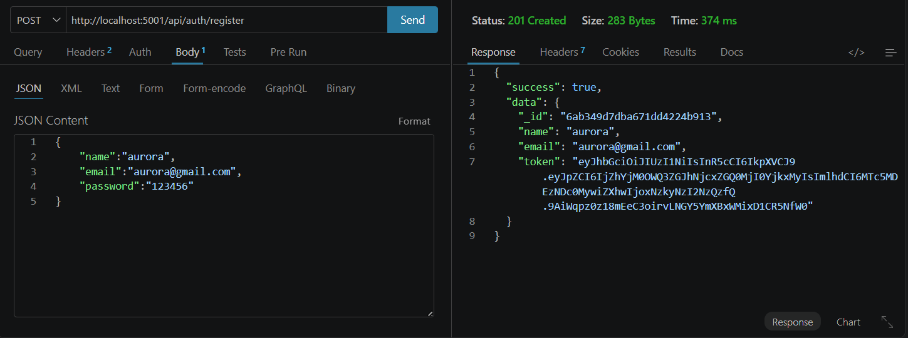
2. Login API
The Login API authenticates an existing user using email and password. After successful login, the system returns a JWT token.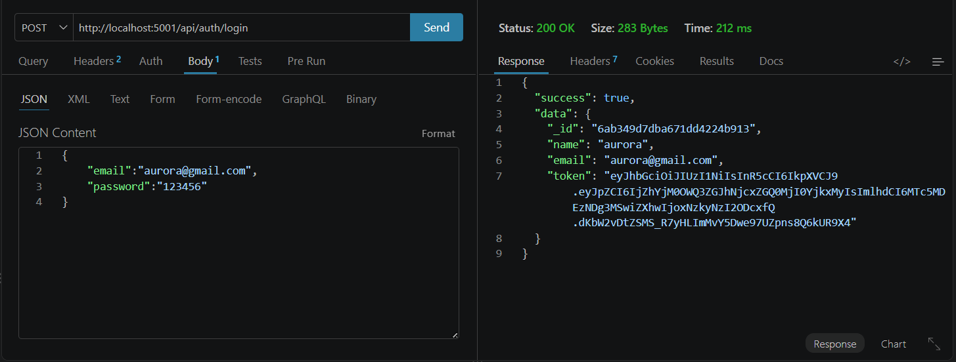
3. Weather API
The Weather API retrieves current weather information for the requested city using the OpenWeather API.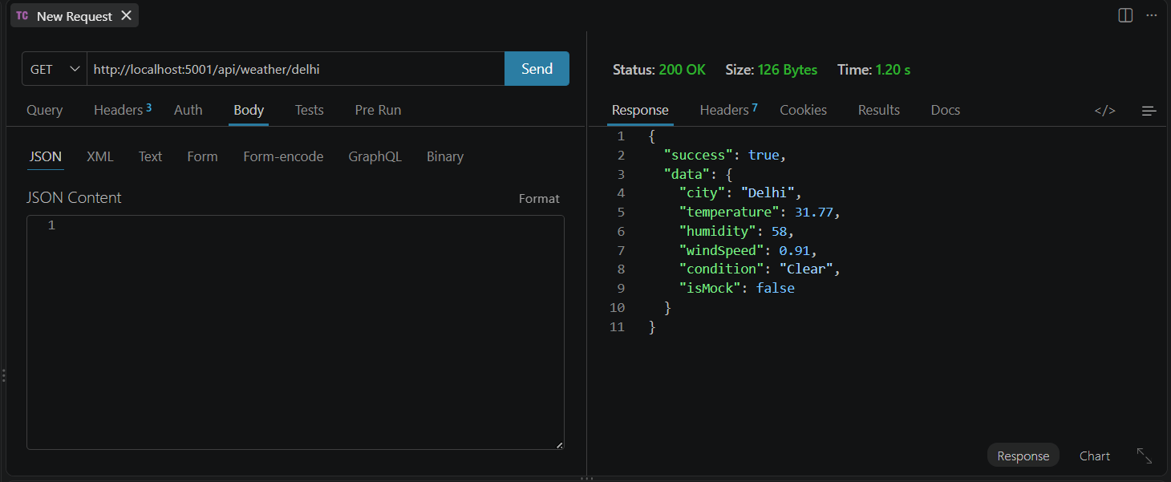
4.Weather Summary API
The Weather Summary API uses Google Gemini AI to generate an easy-to-understand summary from the current weather information.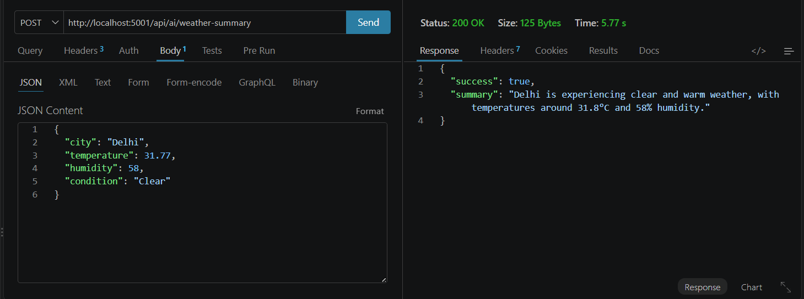
5. Weather Recommendation API
The Weather Recommendation API provides personalized suggestions such as clothing advice, hydration guidance, and outdoor activity recommendations.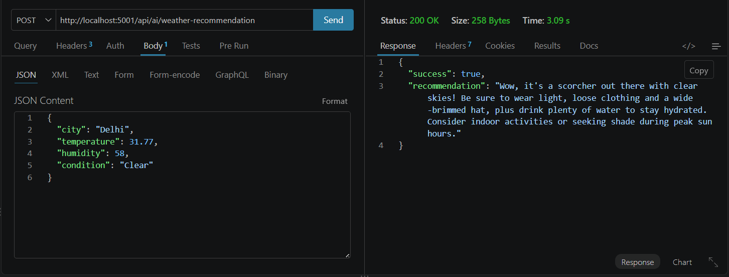
6. Add Favorite Location API
The Add Favorite Location API allows an authenticated user to save a city and country as a favorite location.
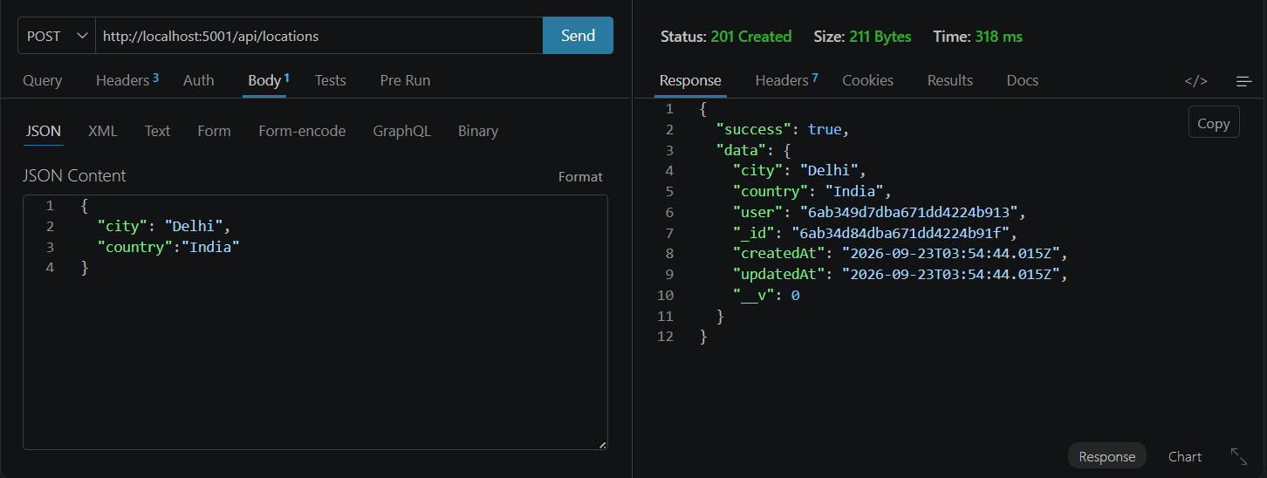
7. View Favorite Locations API
This API retrieves all favorite locations saved by the currently authenticated user.
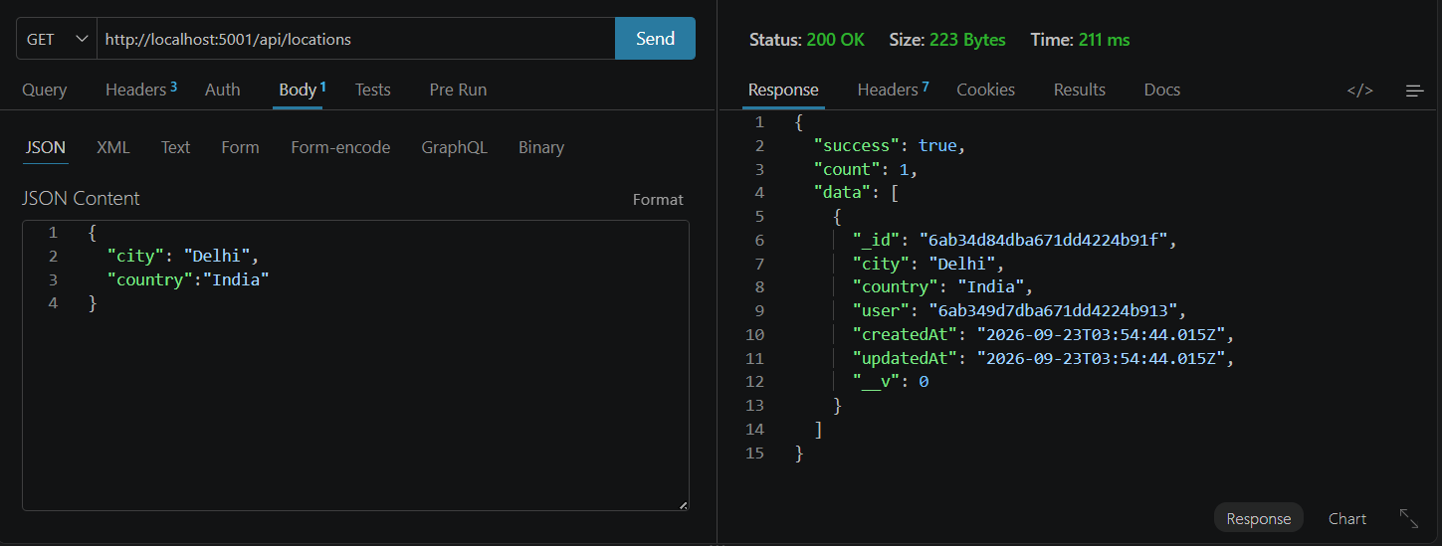
8. Update Favorite Location API
The Update Favorite Location API allows a user to modify an existing saved location.
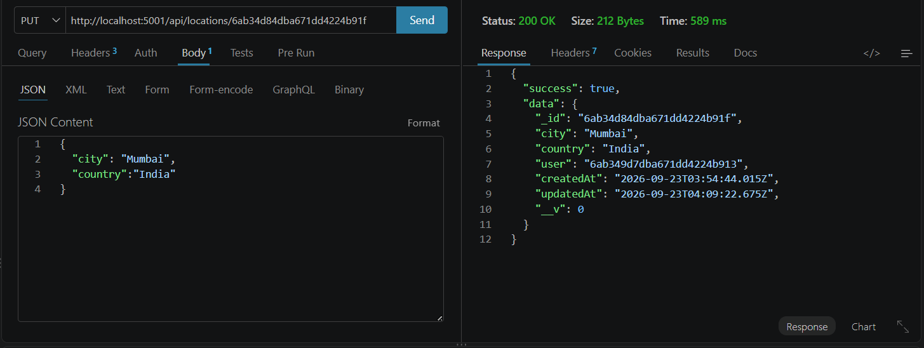
9. Delete Favorite Location API
The Delete Favorite Location API removes a selected favorite location from the user's saved locations.
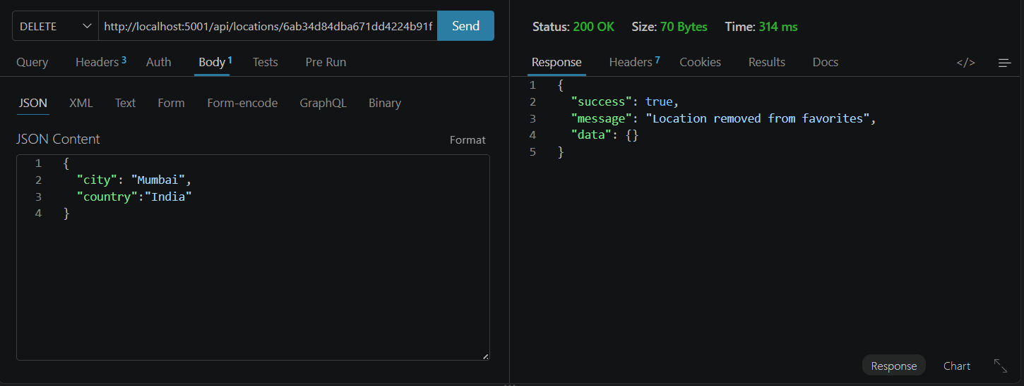
Demo Video: https://drive.google.com/file/d/1EAGve3OlvCGOPe_ErM_p9JeDB-0vX9WK/view?usp=sharing
Demo API: https://drive.google.com/file/d/1b1qGHXGDFAdo9mPUBjxIAb4ir2cmITlL/view?usp=sharing
Code: https://drive.google.com/drive/folders/1lbCVqzrozVsgnhhogt1rUoT4r601OvPc?usp=sharing
Phases: https://drive.google.com/drive/folders/1tpo4gQke86dDi3rfeFnFvDpWd1DqkQc9?usp=drive_link

